**Group Philippines Country Based Database**

**Leader:** Santiago, Kit Nicholas T

**Members:** Casingal John Philip Emmanuel,

Valencia Hans Aaron, Fuentes Carl Daniele

**Project Title:**

Every Juan ‘a: Always Find your Dream Job,

Juan Opportunity at a Time!

**CTINFMGL Information Management Project Proposal**

BSIT – MWA INF 227

March 09, 2024

Submitted to: Ms. Leonila B. Valdez

**PROJECT OBJECTIVES AND PURPOSE**

Every Juan ‘a is your go-to-search platform that caters everyone’s needs for finding jobs and their aspiration for it. Our mission is simple yet profound; we wanted to make job finding accessible for every Filipinos, making it efficient, user friendly and enjoyable for Every Juana. We understand that every job seeker is unique, seeking any possibilities what they would gain in return, what experiences and learnings can they adapt to the environment on the company they are seeking. And that is why we’ve built a platform that offers a wide range of job listing options, from entry level position to executive roles across various industries here in the Philippines.

Our user-friendly interface makes it easy for Every Juan ‘a to browse through thousand job opportunities, filtered by location, industry and experience level and apply with just a few clicks. We also provide valuable resources such as importing their resume, their qualification degree they have finished to showcase to the companies and to the admin that will help them sort and filter out applicants easier. At Every Juan ‘a, we are committed to create a diverse inclusive workplace, we wanted to create a sense of belongingness to other companies that share our values and dedicated to creating a culture of equality. Whether you are a recent graduate, a seasonal professional or someone looking for career change. Every Juana is here to support in the job search.

**DATA DICTIONARY**









**SCREENSHOT UI WITH DESCRIPTIONS**

**Homepage**: In here you can see the about and how to apply page and the Login and Apply Now button for the User Applicants if not registered in the database yet or not created an account yet.

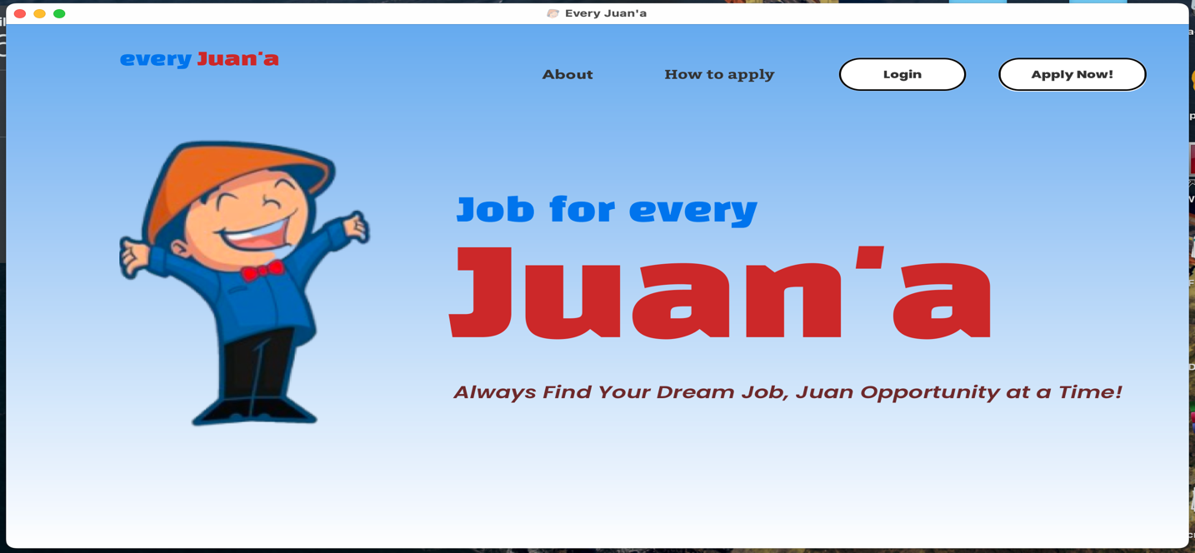

**About Page (Homepage):** Know all about the primary objectives and goal of Every Juan ‘a System Job Database.

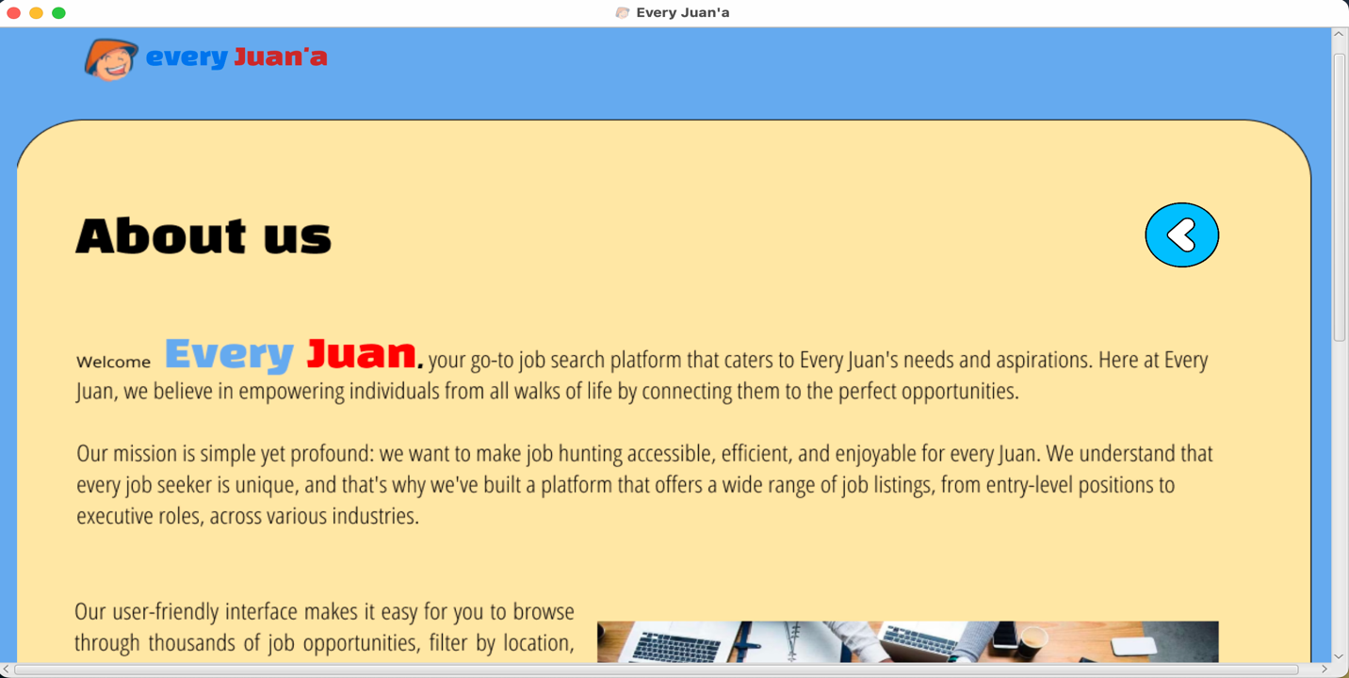

**How to Apply Page (Homepage):** Know all about the basic step by step process to know how to apply if they are using it first time, the system database.

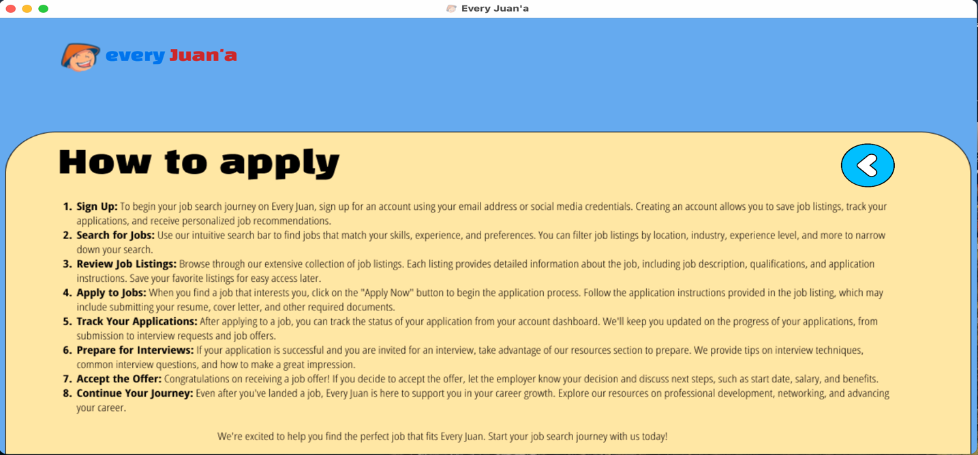

**Login User Applicant and Login Admin Page:** This is where they can navigate to log in to our system based on their username inputted and password indicated in the Registration Page and if they are Admin, they should already know the username and password for it.

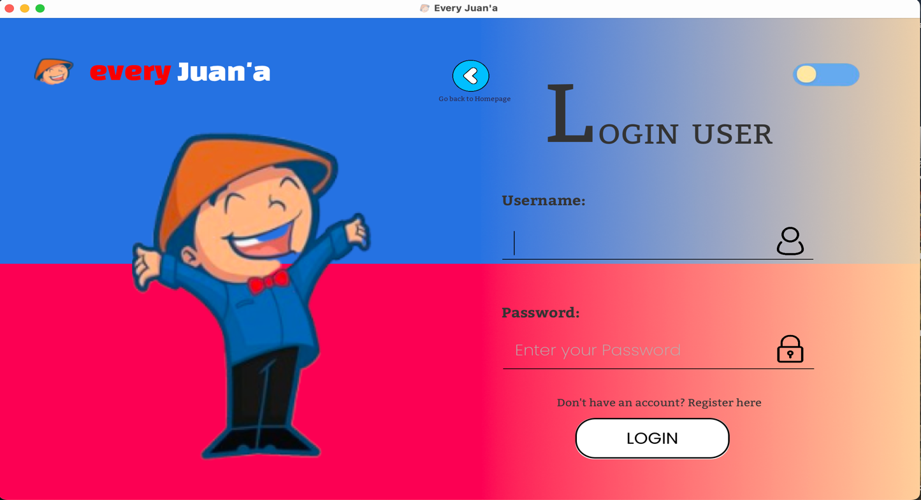

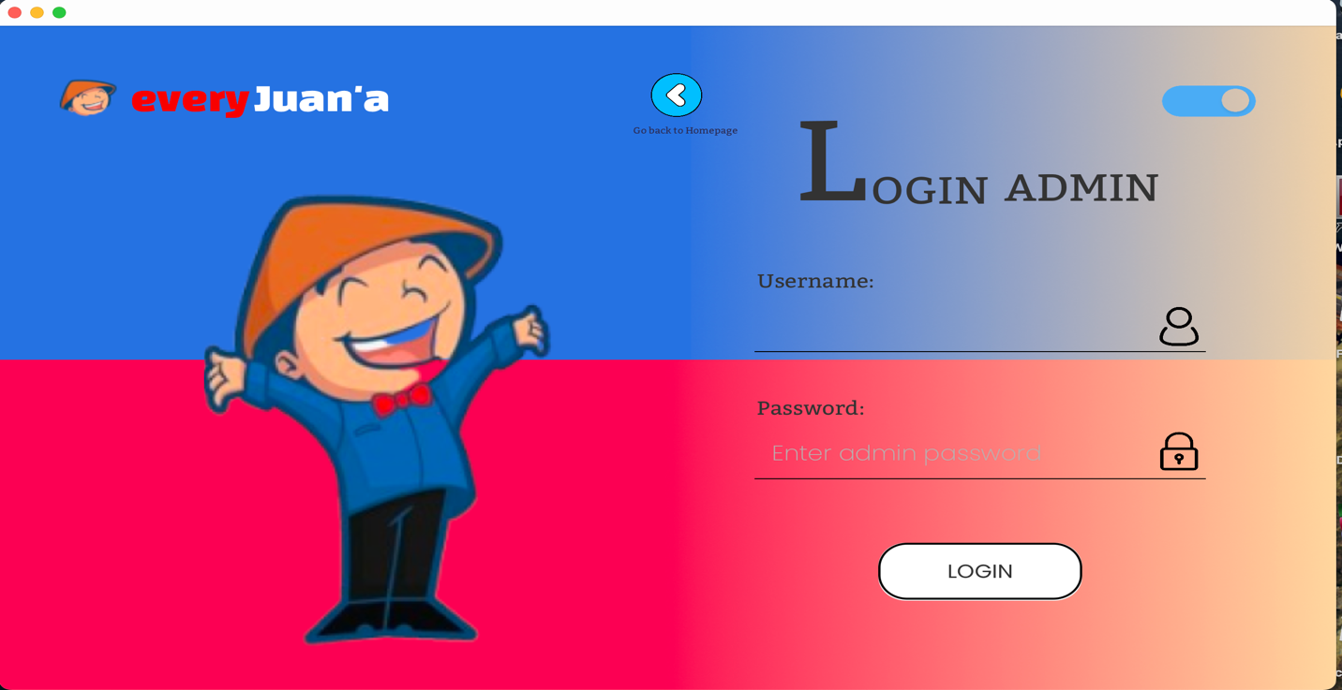

**Registration Page:** When clicked on “**Apply Now! on Homepage”,** it will redirect you to this page in where the Applicants can register their account and their information provided and when it is complete, just click **Save Changes** and it will save it to the database with their ID picture and details provided.

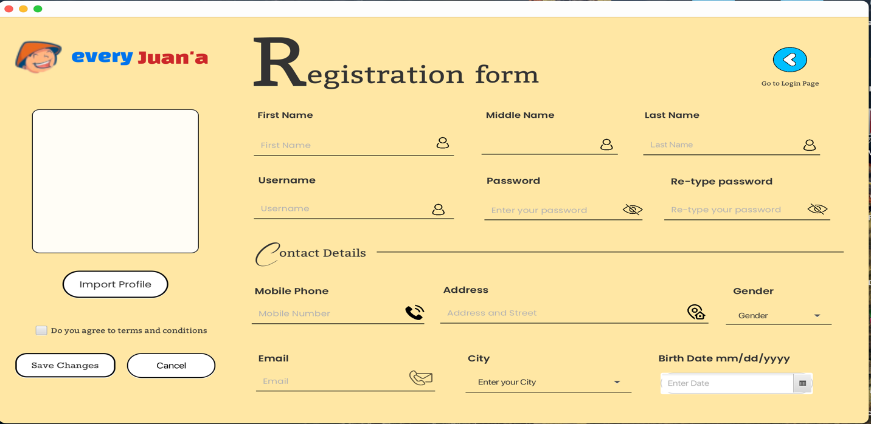

**User Applicant Homepage Profile:** After successfully logged-in, a show alert will pop up to say that your account is successfully logged-in, and you can access the user applicant homepage.

In here, you can see your profile overview, you can see also your profile picture and the username you have inputted below the picture. With the profile overview, you can change details of the applicant’s personal information and update it by clicking **Save Button.**

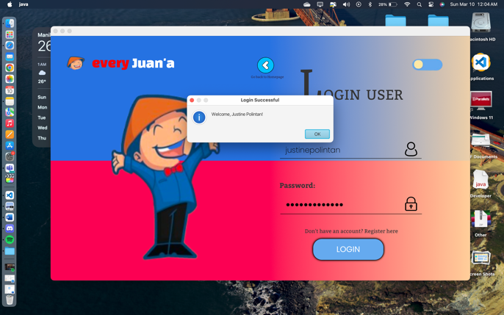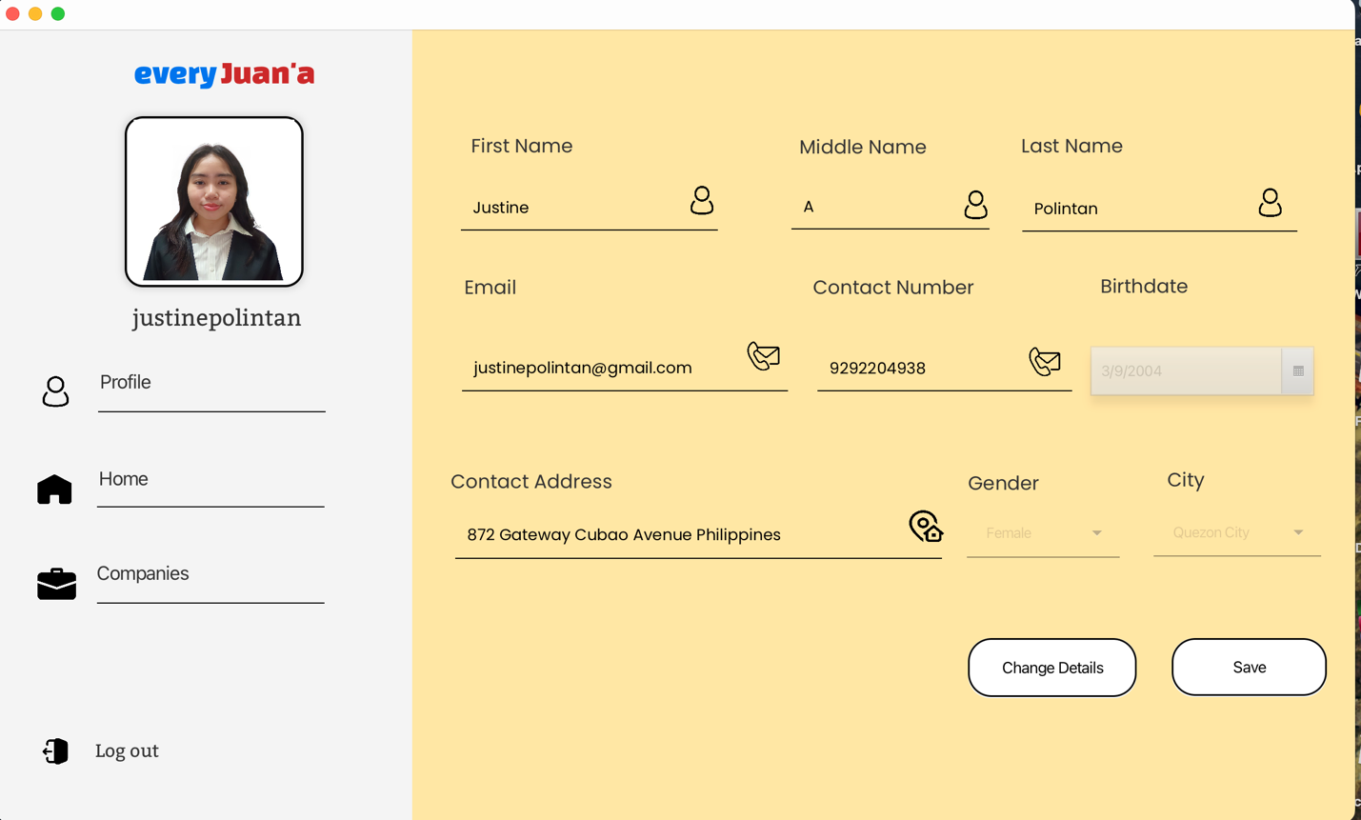

**User Applicant Home:**  Just by hovering to the Home in the right side, you can be directed back to the Homepage, where you can click the About and the How to Apply and know the step-by-step instructions.

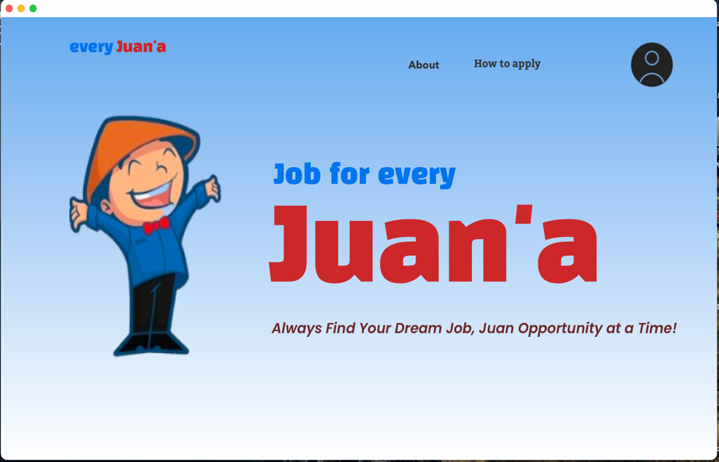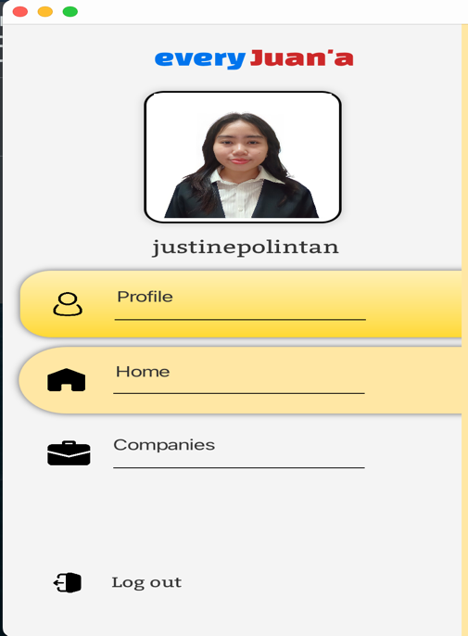

**User Applicant Companies Page:** In here the applicant can scroll down to different kinds of Companies out there that is in inputted in our database system, where they can see the company name, the company address and the available job positions for every company out there, you can also see the company image or the logo for every type of it.

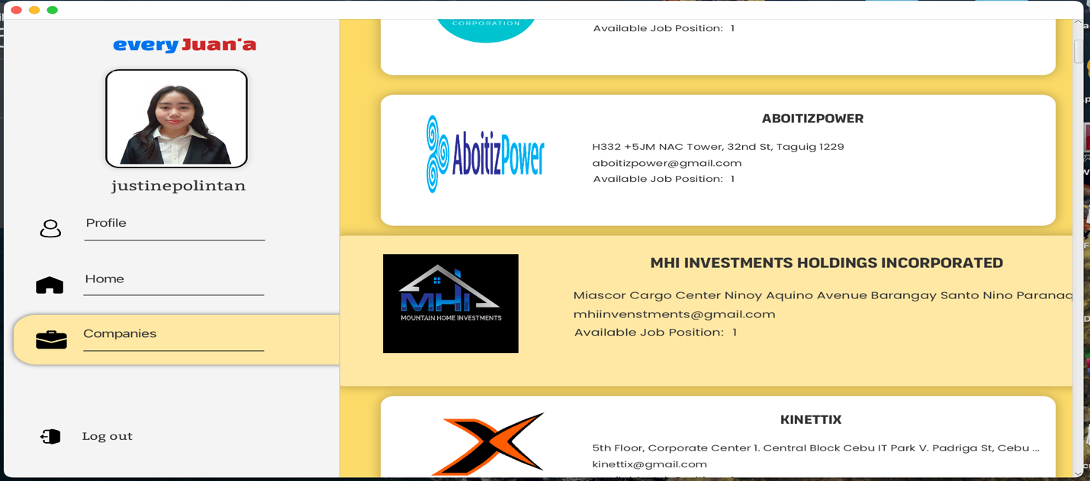

**User Applicant Companies Details Page:** When the user have clicked the companies that they have liked, they can see more about the company information that they have clicked including the job positions available and salary if they have been hired.

And if they really wanted to pursue a job position available here, they can select their finished degree, the job position that they have wanted, and the date they wanted to apply adhering to the last date application deadline for that job. They can also import their resume or curriculum vitae so that it can be directly accessed to the Admin.

After that, it will be saved directly to the database if the apply now is clicked.

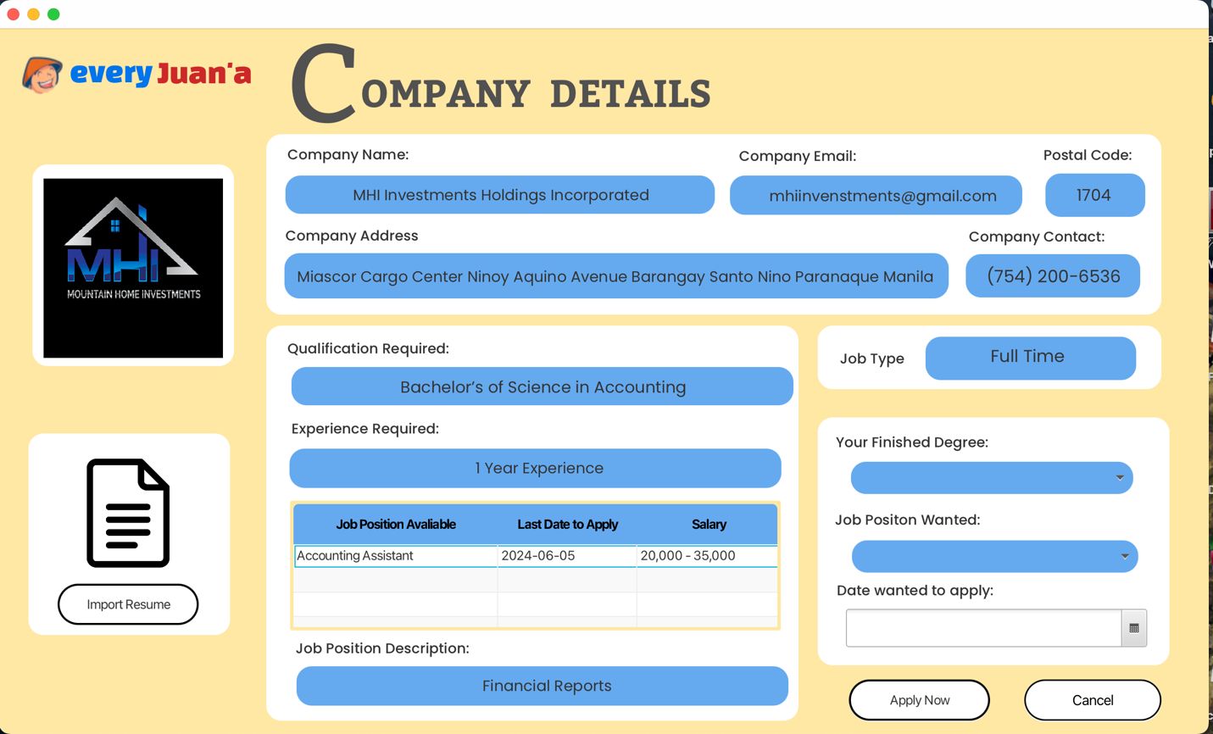

**ADMIN Dashboard Interface Page:** So, in the Login Page for the Admin, when accessed, the first thing that they will see is this dashboard. The dashboard displays all the total users, total companies, total users applied, the total applied based on their degrees, the total applied users by city. The male and female applied position and the total job positions for every job company in our database.

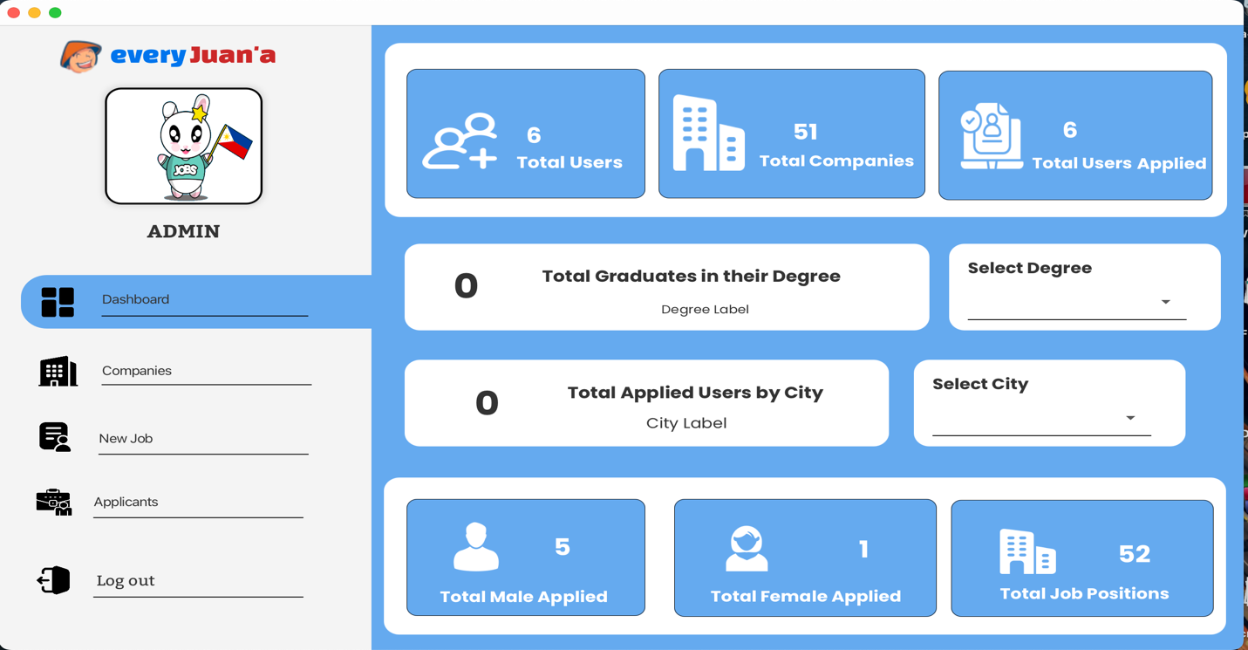

**ADMIN Companies Interface Page:** Here, when you click the Companies, you can edit every information for every company in the database, and update the hiring job position for every company, you can add also the job hiring position for each company at the same time update the company logo if the admin thinks it should be updated to its latest version.

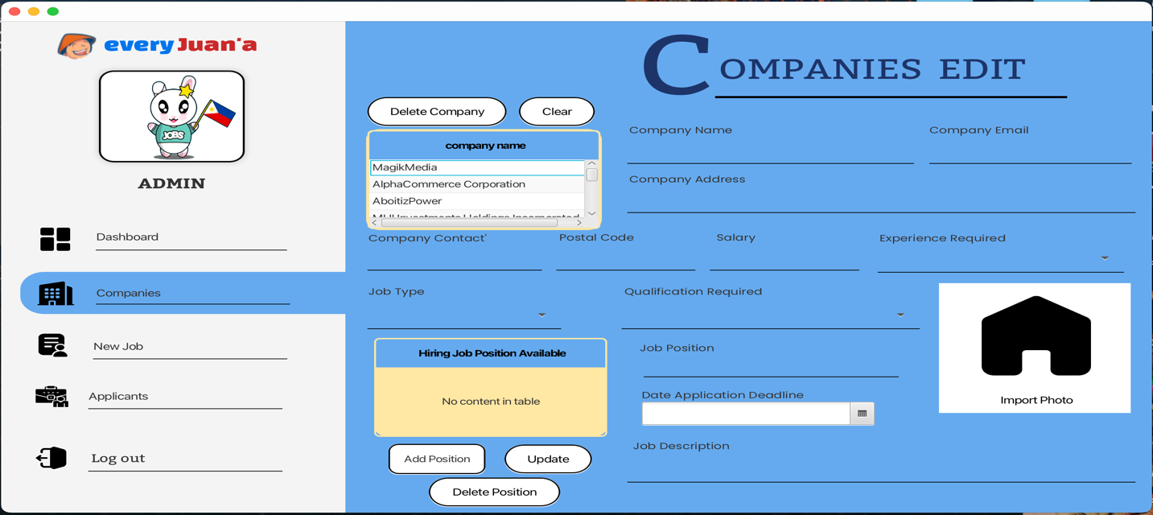

**ADMIN New Job Interface Page:** When you have hovered and clicked the New Job, the Admin of the database can add a new job and new company for the database inserted. You can also import the company logo and add a hiring position for every company you wanted to add. And after all of that you can select the Save All, and it can be inserted also in the database with all the fields have been filled.

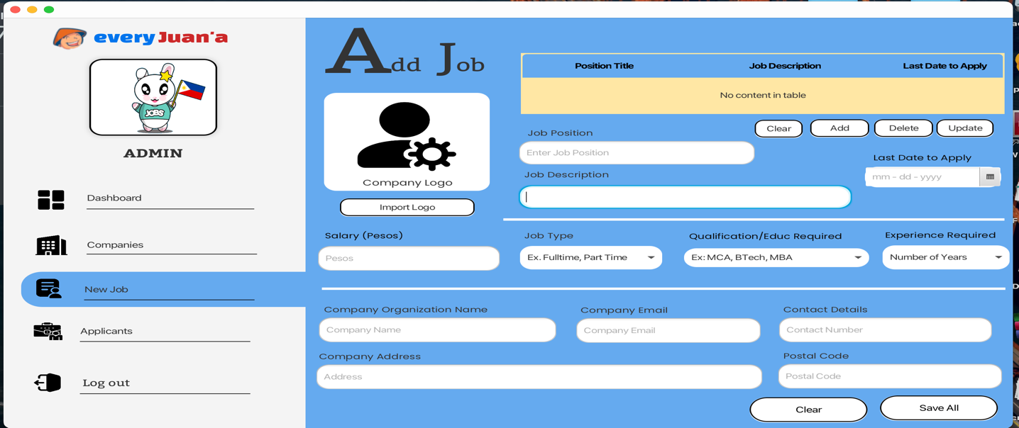

**ADMIN Applied Applicants Interface Page:** Here in this Applied Applicants Page, you can see the different applicants for the different companies that they have applied in the **User Applicants Page,** and in here you can see the applicant’s personal information, the degree that they have took and the company and the job position that they have picked. So, in that, the admin can see who is applying.

And they can see also the View Applications or the resume or the curriculum vitae that they have putted, so it can easily navigate who is applying for that certain company.

